**Basic Instructions to Use Zelle Online With Your Banking Institution’s Website**

* Check out this short videoonhow [Zelle works](https://www.zellepay.com/how-it-works)
* Find out if your [banking institution](https://www.zellepay.com/get-started) uses Zelle

# If you are going to pay using Zelle, please follow the directions below:

1. Login to your banking institution’s website
2. Navigate to the Pay & Transfer/Pay Bills & Quick Pay section
3. If you have never used Zelle before, add new recipient. You may need to select small business.
4. Enter the appropriate information. Recipient name is **California Fire Technology**

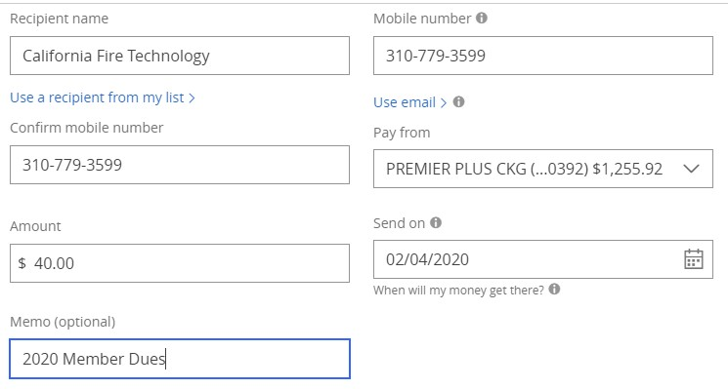

1. Enter mobile number **5624161920**

(DO NOT include **–** or **( )** the system automatically enters these characters).

1. Confirm your entry in the next line.
2. Enter the amount. Current annual dues are

**$40**.

1. In the Memo (optional) section, please enter: **2025 Member Dues**
2. Review your entry and click next.
3. A verification screen comes up, approve and then submit your payment.
4. Once you have completed your payment, complete the 2024 membership dues form and email to Treasurer Ray Mosack, at rmosack@mtsac.edu

# If you or your college is paying by check, please follow the directions below:

* + Type your information into the 2025 membership dues form and print it
  + Mail the completed form and your check to:

**California Fire Technology Directors’ Association c/o Ray Mosack, Treasurer**

**1000 North Grand Ave.**

**Building 28B Room 07**

# Walnut, CA 91789

For questions or concerns, please email **Ray Mosack** at **rmosack@mtsac.edu**

Revised 01/01/2024